IOT Based Antenna Positioning System

All wireless communication systems work on antennas for reception of signals. Proper positioning of antennas is necessary according to satellites/transmitters to achieve effective wireless communication. So here we propose an IOT based antenna positioning system that allows for remotely positioning of antennas based over IOT. Here we use sensor based system with motor on each antenna using antenna to check its facing direction that is transmitted over IOT. If the direction of a satellite or transmitting station changes over time, the antenna direction must also be changed accordingly. The receiving antennas may be placed far apart from each other across the globe. So our system allows for antenna positioning over very long distances. The antenna positions are visible over internet to controlling operator on the IOT GUI. We here use IOT Gecko to develop the antenna monitoring gui system. Our system allows for monitoring antenna direction as well as transmitting new coordinates to position the antenna and motor appropriately positions the antenna accordingly.
Block Diagram :
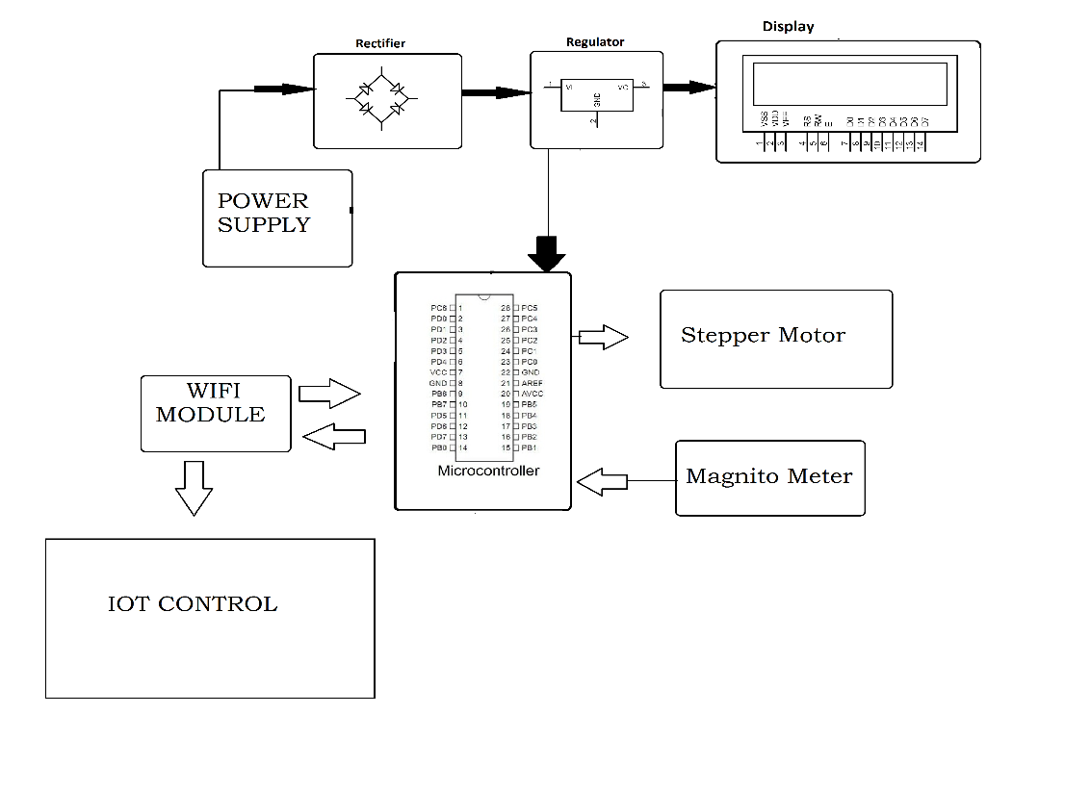
Hardware Specifications :
- Rectifier
- Regulator
- Power Supply
- LCD Display
- Wifi Module
- Atmega 328 Microcontroller
- Stepper Motor
- Magnetic Compass Sensor

Software Specifications :
- Arduino Compiler
- Programming Language: C

